SCM Notes | Session 2: SC Stakeholders, Strategy & Manufacturing Processes
Course: Supply Chain Digitization

1. SC Stakeholders & Their Roles
- Not all stakeholders are present in every SC — depends on SC type
Key players & roles:
- Suppliers: provide/sell RM or components needed for final product
- Manufacturers: convert RM → finished goods (involves various production processes)
- Transporters (Logistics): move RM supplier → manufacturer; move FG → rest of distribution network
- Distributors: store RM & FG; release to next stage based on production schedules / demand
- Retailers: closest to customer; sell FG via online or physical stores
- Consumers: end users — this is where SC terminates

2. Forward SC vs. Reverse SC
- Forward SC: Supplier → Manufacturer → Distributor → Retailer → Customer
- Transporter connects all links; retailer is the last player before customer
- Reverse SC: Customer returns product → flows BACKWARD through the chain
- Return collected by retailer or distributor depending on network design
- Minor repair: handled at retailer/distributor level → product returned to customer
- Major repair/exchange: product goes back to manufacturer
- Why it matters: managing returns = essential for customer satisfaction in today's market
⚠ Key Takeaway: Both forward & reverse SC must be managed — SC now needs to be viewed with 'new lenses'.

3. Value Chain vs. Supply Chain
- Often confused — same processes, but very different focus

Value Chain
- Def: focus on adding value at EACH step — planning, design, development, delivery
- Objective: enhance customer experience → justify premium pricing
- Output: competitive advantage — helps company perform better than rivals
- Example — Coffee Shop:
- Source high-quality coffee beans from renowned region
- In-house roasting to preserve quality
- Welcoming store ambience → comfortable seating
- Personalized service + customization options
- Result: every step adds value → customer pays premium price

Supply Chain
- Def: focus on efficient movement & delivery of goods from supplier → end customer
- Objective: ensure product reaches customer — right manner, right time, customer satisfaction
- Example — Smartphone:
- Source components (microchips, screens, batteries) from global suppliers
- Transport to assembly plants (multiple locations)
- Assemble into finished smartphones
- Distribute to global retailer stores → fulfill customer demand
- Focus: timely component availability, efficient production, minimal wastage, global distribution
Summary: Value Chain = WHY value is added (competitive edge) | Supply Chain = HOW goods move efficiently

4. Competitive Strategy
- Def: searching for a favourable competitive position in an industry; achieving a profitable & sustainable position against market forces (strong brand recognition, economies of scale etc.)
3 Examples of Competitive Strategy:
- Retail chain store: Cost Leadership — large volume, wide product range, offered at LOW cost
- Smartphone brands: Differentiation — frequent new models with new tech; short gap between launches keeps customers hooked
- Hypermarkets: Volume + Low Price — all products under one roof (dept. store + grocery); high volume → low pricing → high footfall
⚠ Key Takeaway: Just as SC ≠ same for all, strategy ≠ same for all companies — depends on competitive position they want in the market.

5. Competitive Priorities
- Def: critical operational dimensions a process/SC must possess to satisfy customers
- Drive decisions on: capacity, technology, production process, planning & control
- Note: company does NOT need all — select the most relevant ones
5 Competitive Capabilities:
- Cost: minimise cost at every step of SC/manufacturing → enables low pricing strategy
- Quality: all products & processes comply with specifications; product accepted on quality basis
- Flexibility: ability to offer varying volumes AND varying product mix
- Delivery: reliable & quick delivery; stock availability when demand arises
- Innovativeness: speed of new product introduction → low time-to-market; fast implementation of new processes

6. Manufacturing Processes (5 Types)
- Competitive priorities → determine which manufacturing process to select
The 5 Types:
- 1. Project: product stays STATIONARY; all processes brought to it | Ex: construction, ships, aircraft | Very LOW volume, VERY HIGH variety
- 2. Job Shop: work centres group similar tasks/equipment; product moves through relevant centres | Ex: custom furniture workshop | Low-medium volume, HIGH variety → jumbled material flow
- 3. Batch Production: goods made in batches; each batch goes through same series of steps | Ex: baking | Medium volume, medium variety → disconnected line flow
- 4. Assembly Line: high volume, standardised items; products move through stations in sequence | Ex: automobile manufacturing | HIGH volume, LOW variety
- 5. Continuous Process: uninterrupted flow; fixed sequence of steps; common for liquids/gases | Ex: petroleum refining | VERY HIGH volume, VERY LOW variety → continuous flow
Volume vs. Variety Matrix (exam-ready):
- Project → Volume: ▼▼▼ Variety: ▲▲▲ Flow: stationary
- Job Shop → Volume: ▼▼ Variety: ▲▲▲ Flow: jumbled
- Batch → Volume: ▼▲ Variety: ▲▼ Flow: disconnected line
- Assembly → Volume: ▲▲ Variety: ▼▼ Flow: sequential
- Continuous → Volume: ▲▲▲ Variety: ▼▼▼ Flow: continuous
Rule of thumb: Moving from Project → Continuous = increasing standardisation, increasing volume, decreasing variety
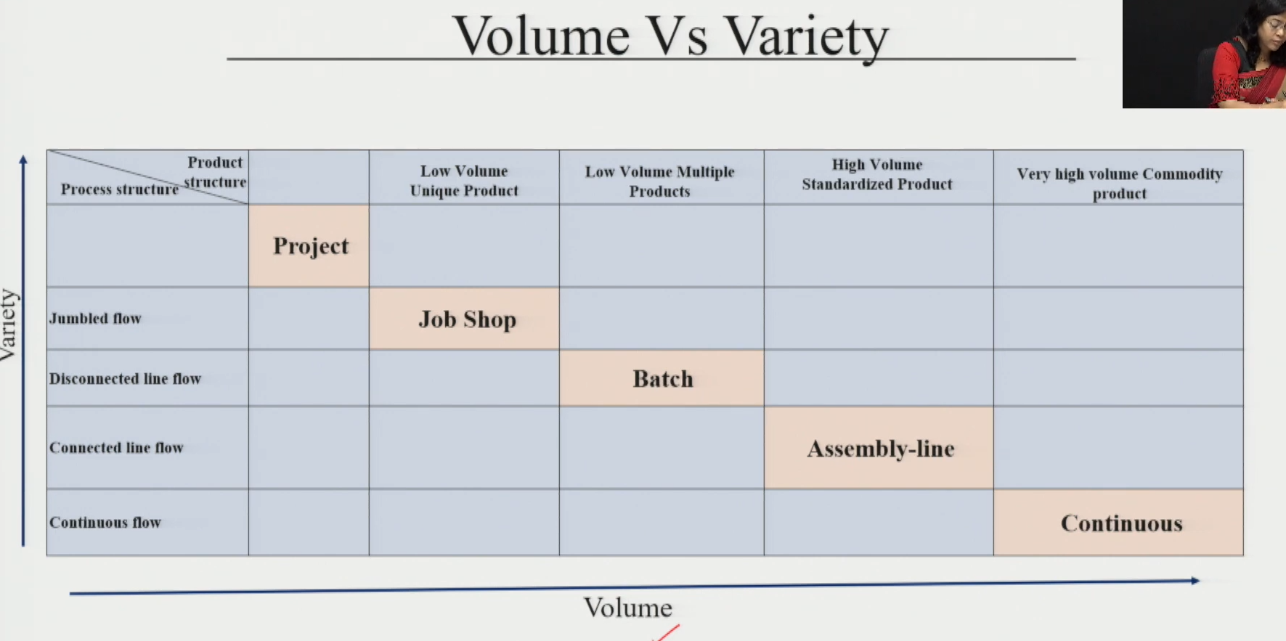

7. Linking It All Together
- Competitive Strategy → Competitive Priorities → Manufacturing Process → SC Type
SC Types (linked to mfg process):
- Responsive SC: product reaches customer FAST, as per customer requirement — linked to high-variety production (job/batch)
- Efficient SC: focus on delivering at MINIMUM COST — linked to high-volume standardised production (assembly/continuous)
✓ Exam Angle: "How does competitive strategy translate into SC design?" → Strategy → Priorities (cost/quality/flexibility/delivery/innovativeness) → Mfg Process → Responsive or Efficient SC. Use examples from the session.

